1. **Connection Establish and Database creation**

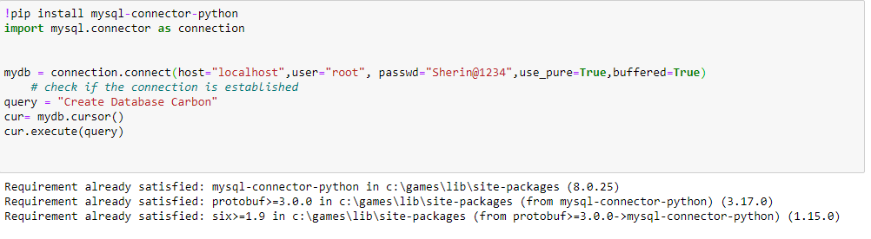

1. **Table Creation**

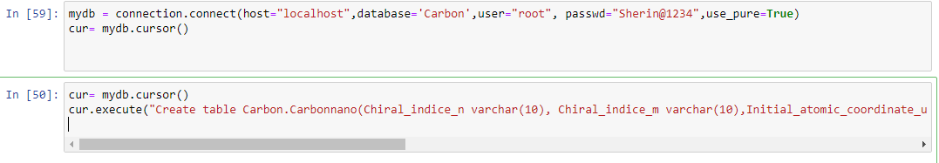

1. **Data Insertion from CSV to SQL Database**

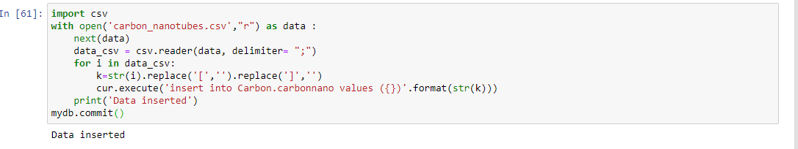

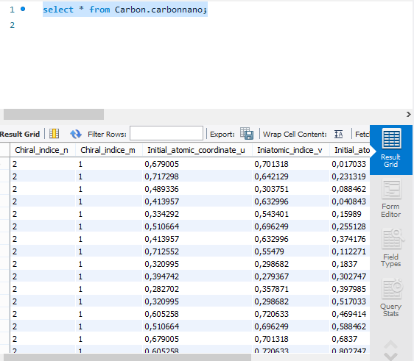

1. SELECT QUERY



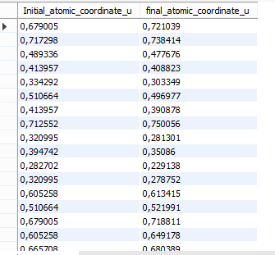

1. **DISTINCT Clause**



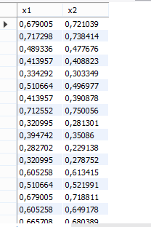

1. **WHERE Clause**



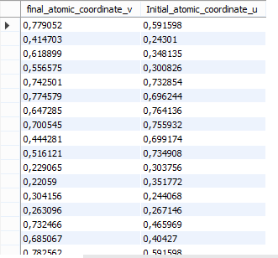

1. **MULTIPLE CONDITIONS**



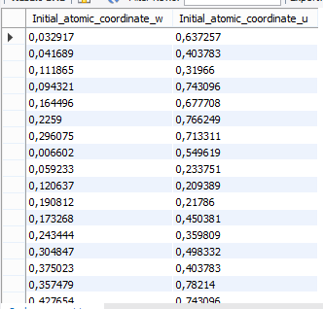

1. **UPDATE Clause**



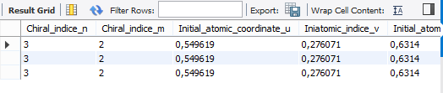

1. **WHERE NOT Clause**



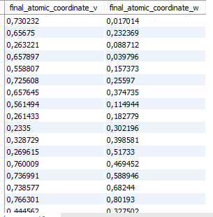

1. **ORDER BY Clause**



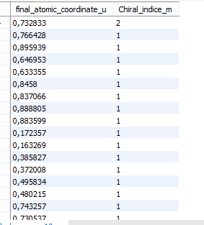

1. **LIMIT Clause**



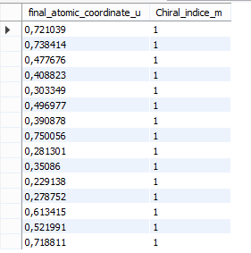

1. **MIN(),MAX()**





1. **COUNT()**



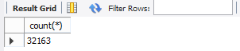

1. **LIKE(‘%x’)**



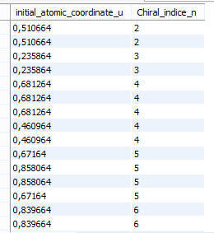

**LIKE(‘%x’)**



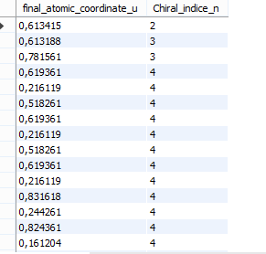

1. **SQL IN**



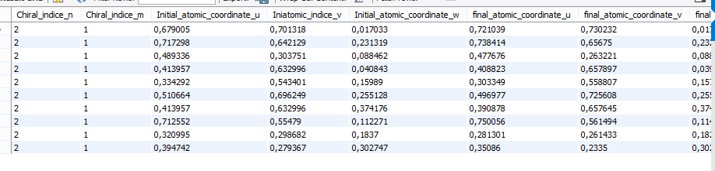

1. **SQL NOT IN**



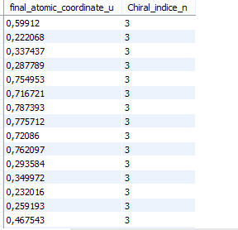

1. **BETWEEN Clause**



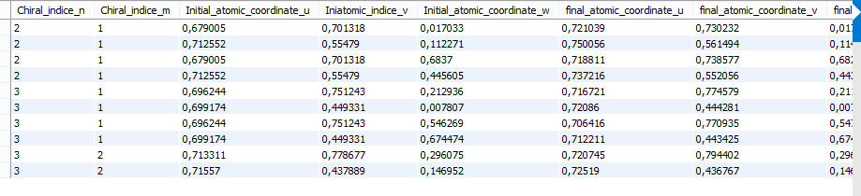

1. **LIMIT Clause**



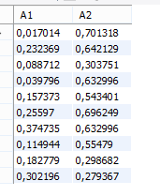

1. **GROUP BY**



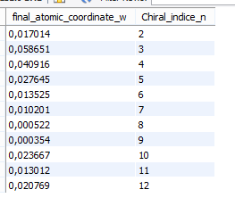

1. **HAVING Clause**



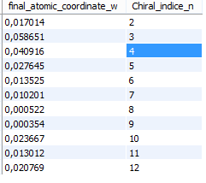

1. **LIMIT Clause**





1. **UNION & UNION ALL**





1. **INNER JOIN**

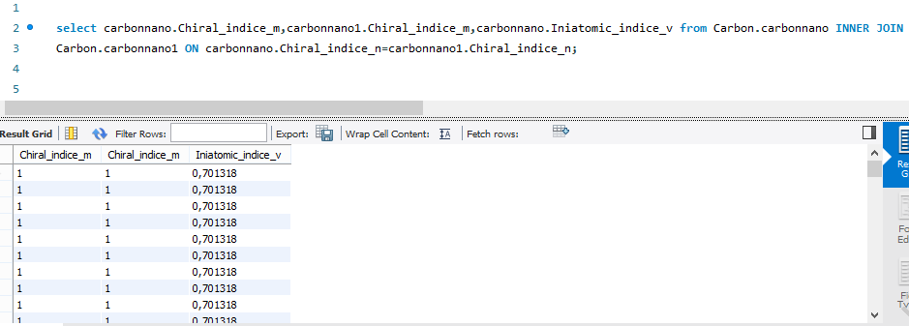

1. **LEFT JOIN**

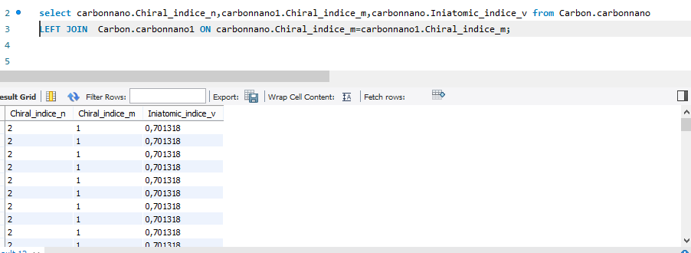

1. **RIGHT JOIN**

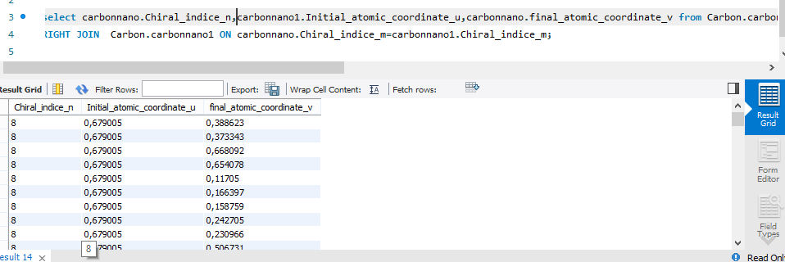

1. **DELETE**

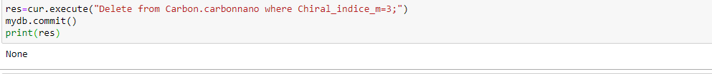

1. **ALTER**

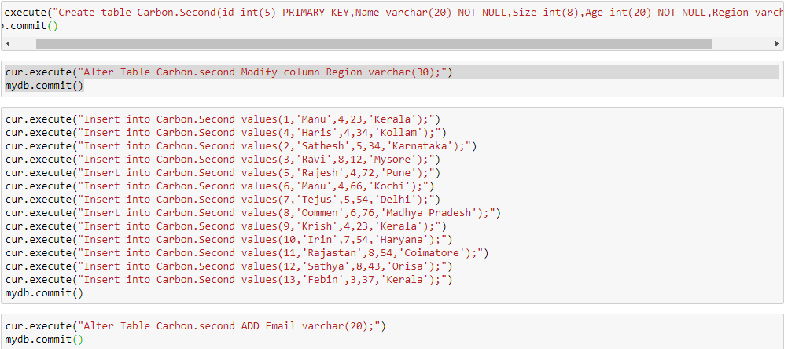

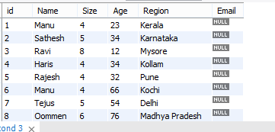

1. **CHECK Clause**

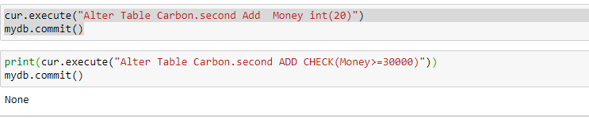

1. **DEFAULT**

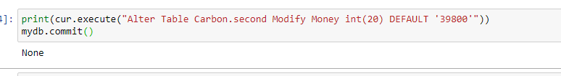

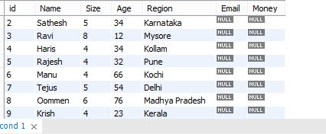

1. **UNIQUE Columns name**

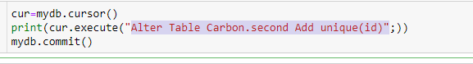

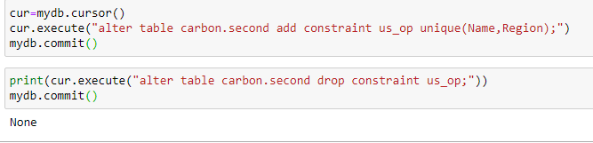

1. **Foreign Key**

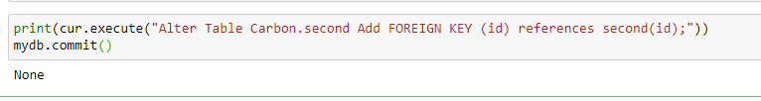

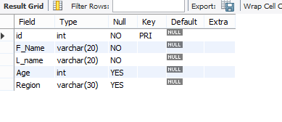

1. **Check constraint**

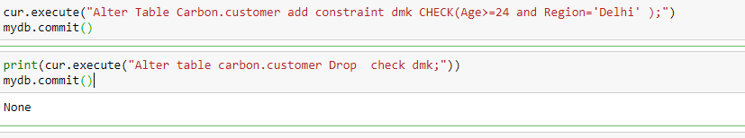

1. **Index on columns**

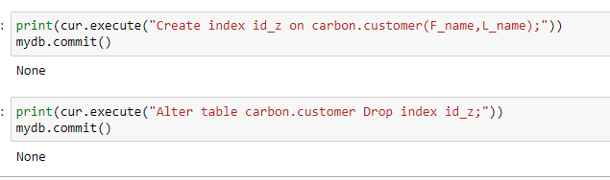

1. **Stored Procedure**

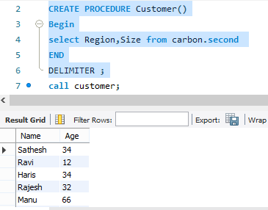

**35.Stored Procedure (input parameter)**

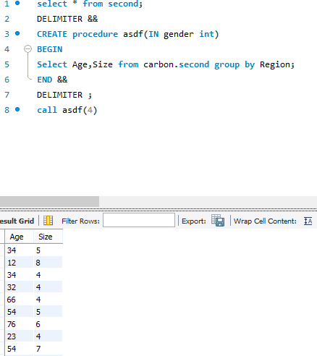

**36. Drop Stored Procedure**

